CHAPTER 3-5

pushdown automata

- REs are equivalent to FSMs. Concepts such as the Pumping Theorem were learned from FSMs, not REs.
- We want to answer the same questions about CFLs, so we would also like a computational formalism that is powerful enough to enable us to build a machine for every CFL.
- A pushdown automaton, or PDA, is a finite state machine that has been augmented by a single stack.
- We define a PDA M to be a sextuple (K, Σ, Γ, Δ, s, A), where K is a finite set of states, Σ is the input alphabet, Γ is the stack alphabet, s∈K is the initial state, A⊆K is the set of accepting states, and Δ is the transition relation which is a finite subset of (K × (Σ∪{ε}) × Γ*) × (K × Γ*)
state input letter string of state string of
or ε symbols symbols
to pop to push
- A transition ((q₁, c, γ₁), (q₂, γ₂)) means the following:
  - M may take the transition from q₁ to q₂ if the input is c and string γ₁ matches the top of the stack. If it does and the transition is taken, then M reads c, pops γ₁, and pushes γ₂.
- A configuration of M is an element of K×Σ*×Γ*:
  - Its current state
  - The input that is still left to be read
  - The contents of its stack
- The initial configuration of M is (s, w, ε), where w is the input string.
- We will use the following convention for describing M's stack as a string:
  - The top of the stack is to the left of the string
c will be written as cab
a
b

  - If a sequence c₁c₂…c_{n} of characters is pushed onto the stack, they will be pushed rightmost first.
c₁
c₂
…
c_{n}
…

- We define the relation yields-in-one-step, |-, which relates config₁ to config₂ iff M can move from config₁ to config₂ in 1 step. Thus, (q₁, cw, γ₁γ) |- (q₂, w, γ₂γ) iff ((q₁, c, γ₁), (q₂, γ₂))∈Δ where c is any element of Σ∪{ε}, γ₁, γ₂ and γ are any elements of Γ*, and w is any element of Σ*.
- Let |-* be yields-in-0-or-more-step. C₁ yields configuration C₂ iff C₁ |-* C₂
- A computation by M is a finite sequence of configurations C₀, C₁, …, C_{n} for some n≥0 such that:
  - C₀ is an initial configuration,
  - C₀ |- C₁ |- C₂ |-… |- C_{n}.
- Note Δ is a transition relation, not a transition function. Thus we allow nondeterminism. Thus by definition, a PDA means a NDPDA.
- If M is in some configuration (q₁, s, γ) it is possible that:
  - Δ contains exactly one transition that matches. In this case, M makes the specified move.
  - Δ contains more than one transition that matches. In this case, M chooses one of them.
  - Δ contains no transition that matches. In this case, M halts.
- A computation C of M is an accepting computation iff C=(s, w, ε) |-* (q, ε, ε), and q∈A. Note that a computation accepts only if it runs out of input when it is in an accepting state and the stack is empty. Note also that once M is in (q, ε, ε) and q∈A, M halts even if there is a legal move to take (read nothing, pop nothing, and push something).
- A computation C of M is a rejecting computation iff C=(s, w, ε) |-* (q, w′, α) and C is not an accepting computation and M has no moves that it can make from (q, w′, α).
- M accepts a string w iff at least one of its computations accepts.
- M rejects a string w iff all of its computations reject.
- It is possible that M neither accepts nor rejects a string w. That is, it is possible for a computation C of M to loop forever. For example, M can read nothing and keep pushing things on its stack.
  - NDFSM can loop forever too. However, we can always convert a NDFSM to a DFSM to eliminate such infinite loop. NDFSM is really just a design tool. But we will prove that we cannot always convert a NDPDA to a DPDA.
- The language accepted by M, denoted L(M), is the set of all strings accepted by M.
- In all the examples that follow, we will draw a transition ((q₁, c, γ₁), (q₂, γ₂)) as an arc from q₁ to q₂ labeled c/γ₁/γ₂. Such a transition should be read to say "if c matches the input and γ₁ matches the top of the stack, the transition from q₁ to q₂ can be taken, in which case c read, γ₁ popped, and γ₂ pushed". If c=ε, then the transition can be taken without consuming any input. If γ₁=ε, the transition can be taken without popping anything. If γ₂=ε, nothing is pushed when the transition is taken.

Ex3-5-1 A PDA for Balanced Parentheses, Bal
M = (K, Σ, Γ, Δ, s, A), where:
K = {s}
Σ = {(, )}
Γ = {(}
A = {s}
Δ = { [[s, (, ε], [s, ( ]],
[[s, ), ( ], [s, ε]] }
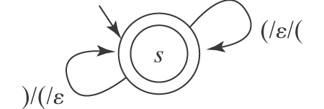
If M sees a (, it pushes ( onto the stack. If M sees a ) and if there is a ( that can be popped off the stack, M does so. If M sees a ) and there is no ( to pop, M halts. If, after consuming its entire input string, M's stack is empty, M accepts; otherwise, M rejects. Remember that M only accepts if when it consumes its entire input string, it is in an accepting state and its stack is empty.
[s, ()(), ε] |- [s, )(), ( ] |- [s, (),ε ] |- [ s, ), ( ] |- [s, ε, ε]
So, M will reject ((), even though it will be in state s, an accepting state, when it runs out of input. The stack at that point will contain (.
[s, ((), ε] |- [s, (), (] |- [s, ), ((] |- [s, ε, (]
Note that the machine accepts ε

Ex3-5-2 A PDA for A^{n}B^{n} = {a^{n}b^{n}: n≥0}
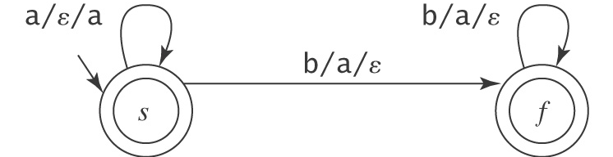
Note that the machine accepts ε

Ex3-5-3 A PDA for {wcw^{R}: w∈{a, b}*}
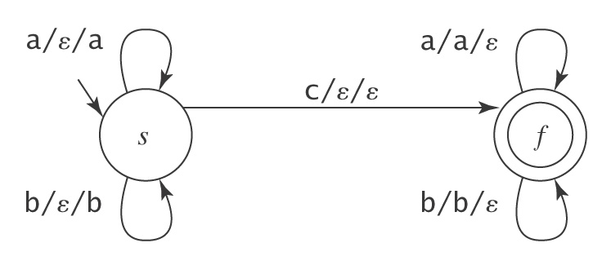

Note that the machine does not accepts ε

- As a short hand, instead of drawing multiple arcs from s to f, we can draw 1 arc with multiple labels separated by commas. So the above PDA can be redrawn as:
b/ε/b, b/b/ε,

- The definition that we have chosen to use for a PDA is flexible in that it allows several symbols to be pushed or popped from the stack in 1 move.

Ex3-5-4 A PDA for A^{n}B^{2n} = {a^{n}b^{2n}: n≥0}
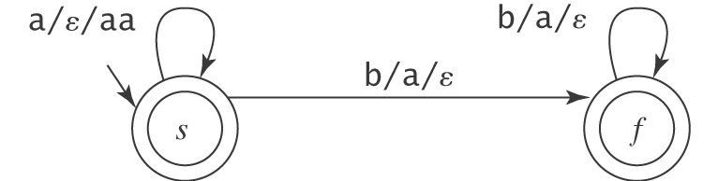

Ex3-5-5 A PDA for L={w∈(a,b)* | w has a double letter}

a/ε/ε a/ε/ε
-

b/ε/ε a/ε/ε
+
b/ε/ε b/ε/ε a/ε/ε, b/ε/ε

From this example, we can see that any regular language can be accepted by a PDA since a PDA is just a FSM with a stack. To accept a regular language, the PDA does not use the stack.

- A PDA M by definition is nondeterministic. So, when we say a PDA, we usually mean a NDPDA.
- A PDA can be deterministic of course. In particular, a DPDA M is deterministic iff during the operation of M, there is always at most 1 move M can make. So far, all of the PDAs we have built have been deterministic.
- As with FSMs, the easiest way to envision the operation of a NDPDA M is as a tree, where each node in the tree corresponds to a configuration of M and each path from the root to a leaf corresponds to one computation that M might perform.
- Can we simulate a NDPDA using a DPDA using the technique similar to algorithm ndfsmToDfsm which simulates a NDFSM using a DFSM?
  - The answer is no. This is because the stack can be different along different paths, and we only have 1 stack.
- An NDPDA cannot always be converted to a DPDA. Unlike FSMs, the set of languages accepted by NDPDAs is not the same as that accepted by DPDAs.
- The set of languages accepted by DPDAs is a proper subset of the set of languages accepted by NDPDAs (a DPDA is a NDPDA, but a NDPDA might not be a DPDA).
- We will see that the set of languages accepted by NDPDAs is the set of CFLs

Ex3-5-6 A NDPDA for L={w∈(a,b)* | w has a double letter}
a/ε/a,b/ε/b a/ε/ε,b/ε/ε, ε/a/ε, ε/b/ε
-
+

a/a/ε,b/b/ε

M is nondeterministic because when it reads an a and the stack has a on top, it has 2 choices. It can push an a, or it can pop the stack. If there is a double letter in the input string, the first of which we push, the second we pop and go to the accept state, where we read everything and pop everything.

Ex3-5-7 A NDPDA for EvenPalindrome ={ww^{R}: w ∈ {a, b}*}
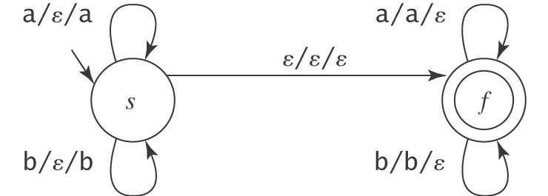
M is nondeterministic because before each character is read, it has 2 choices. It can guess that it has not yet gotten to the middle, in which case it stays in state s and pushes each symbol it reads, or it can guess that it has reached the middle, in which case it takes the ε-transition to state f where it pops one symbol for each symbol that it reads.

Ex3-5-8 A NDPDA for {w∈{a, b}* : #_{a}(w) = #_{b}(w)} =EQUAL
We do not know the order in which the a's and b's will occur. They can be interleaved. The only way to count the number of characters that have not yet found their mates is to use the stack. So the stack will sometimes count a's and sometimes count b's. It will count whatever it has seen more of.
Counting a's counting b's
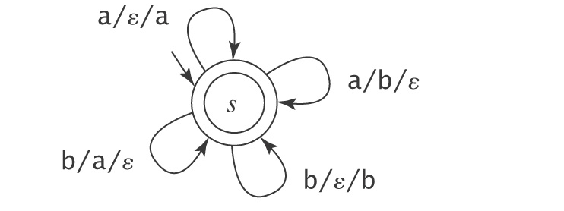
This machine is nondeterministic. Whenever it sees an a in the input with a b on stack, it can either push it or pop b. All the computations that make the wrong guess will fail to accept.

Ex3-5-9 A NDPDA for {w ∈ {a, b}* : #_{a}(w) = 2⋅#_{b}(w)} e.g., aab, baa, aba, abaaba
-+
a/ε/a, b/aa/ε a/b/ε, b/ε/bb

b/a/b
The idea is that we only need one state. The stack will do all the work. It will count whatever it is ahead on. If the machine is counting a’s, then each a will push an a and each b will pop 2 a's. If the machine is counting b’s, then each b will push 2 b's and each a will pop 1 b. The only tricky case arises with inputs like aba. M will start out counting a’s and so it will push 1 a onto the stack. Then comes 1 b. It wants to pop 2 a’s, but there’s only 1. So it will pop that one and then switch to counting b’s by pushing a single b. The final a will then pop that b.

- An important fact about the CFLs, in contrast to the RLs, is that nondeterminism is more than a convenience design tool.
  - We will prove that there are CFLs that cannot be accepted by a DPDA. Thus, there is no equivalent of the regular language algorithm ndfsmToDfsm for CFLs.
  - However, there are techniques that can be used to reduce nondeterminism.

Ex3-5-10 A NDPDA for L={a^{m}b^{n} : m≠n; m, n>0}
Start with the case where n = m
a/ε/a b/a/ε
-1
a^{n}b^{n}Removed
2
b/a/ε

At 2, if input is empty but stack is not (m>n), we accept:
a/ε/a b/a/ε ε/a/ε
-1
a^{n}b^{n}Removed 2

+InputEmptyStackNot
3
b/a/ε ε/a/ε

At 2, if stack is empty but input is not (m<n), we accept:
a/ε/a b/a/ε ε/a/ε
-1
a^{n}b^{n}Removed 2

+InputEmptyStackNot
3
b/a/ε ε/a/ε

b/ε/ε
+ stackEmptyInputNot
4
b/ε/ε

This machine is nondeterministic. At state 2, if M reads b and the top of stack is a, it has 3
choices:
- It can read b, pop a, and push nothing and go to state 2.
- It can read nothing, pop a, and push nothing and go to state 3.
- It can read b, pop nothing, and push nothing and go to state 4.

Techniques for Reducing Nondeterminism

- Nondeterminism can arise from 2 very specific circumstances:
  - A transition that should be taken only if the stack is empty competes against 1 or more moves that require a match of some string on the stack. For example, b/ε/ε from 2 to 4 competes against b/a/ε from 2 to 2 in Ex3-5-10. b/ε/ε should only be taken if stack is empty.
  - A transition that should be taken only if the input is empty competes against 1 or more moves that require a match against a specific input character. For example, ε/a/ε from 2 to 3 competes against b/a/ε from 2 to 2 in Ex3-5-10. ε/a/ε should only be taken if input is empty.
Both of these circumstances are common, so we would like to find a way to reduce or eliminate the nondeterminism that they cause.
- We first consider the case in which nondeterminism could be eliminated if it were possible to check for an empty stack. Any PDA M that would like to be able to check for empty stack can simply, before it does anything else, push a special character onto the stack. The only thing we have to be careful about this is that, before M can accept a string, its stack must be completely empty. So the special character must be popped whenever M reaches an accepting state.

Ex3-5-11 A NDPDA for L={a^{m}b^{n} : m≠n; m, n>0} using a bottom of stack marker #
a/ε/a b/a/ε ε/a/ε, ε/#/ε
1
a^{n}b^{n}
2

+ InputEmptyStackNot
3
-0
ε/ε/# b/a/ε ε/a/ε

b/#/ε
+ stackEmptyInputNot
4
b/ε/ε

Now the transition back to state 2 no longer competes with the transition to state 4. But the machine is still nondeterministic, since the transition back to state 2 competes with the transition to state 3.

- We next consider the "out of input" problem. To solve that one, we will make a change to the input language. Instead of building a machine to accept a language L, we will build one to accept L$, where $ is a special end-of-string marker.

Ex3-5-12 A DPDA for L={a^{m}b^{n} : m≠n; m, n>0} using a end-of-string marker $
a/ε/a b/a/ε ε/a/ε, ε/#/ε
1
a^{n}b^{n}
2

+ InputEmptyStackNot
3
-0
ε/ε/# b/a/ε $/a/ε

b/#/ε
+ stackEmptyInputNot
4
b/ε/ε,$/ε/ε

Now the transition back to state 2 no longer competes with the transition to state 3, since the latter can only be taken when $ is read. Note that we must be careful to read the $ on all paths, and not just the one where we needed it.

Homework problems

            - Build a PDA to accept BalDelim = {w : where w is a string of delimiters: (, ), [, ], {, }, that are properly balanced}.

            - Build a PDA to accept {w ∈ {a, b}* : w = w^{R}}.

            - Build a DPDA to accept L$, where L = {w ∈ {a, b}* : #_{a}(w) = #_{b}(w)}. Hint: We have seen in Ex3-5-8 an NDPDA which accepts L. Use a bottom of stack marker # so that M can tell what it should be counting. If the top of the stack is an a, it is counting a’s. If the top of the stack is a b, it is counting b’s. If the top of the stack is #, then it isn’t counting anything yet. So, if it is reading an a, it should start counting a’s. If it is reading a b, it should start counting b’s.

